SESSION 2

By Harsh R – 1BG17CS031

<!DOCTYPE html>

<html>

<head>

<title>HTML marquee Tag</title>

</head>

<body>

<marquee>This is basic example of marquee</marquee>

<marquee direction = "up" bgcolor="red">The direction of text will be from bottom to top.</marquee>

</body>

</html>

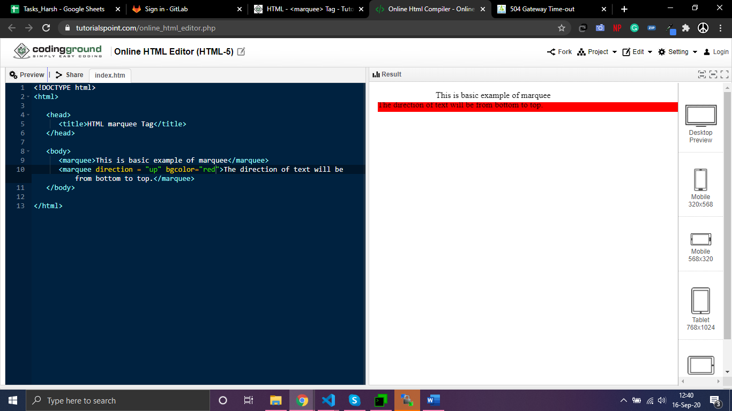

<html>

<head>

</head>

<body>

<table border="10" cellpadding="10" cellspacing="10">

<thead>

<tr>

<td>Column1</td>

<td>Column2</td>

</tr>

</thead>

<tbody>

<tr>

<td>Row 11</td>

<td>Row 12</td>

</tr>

</tbody>

</table>

</body>

</html>

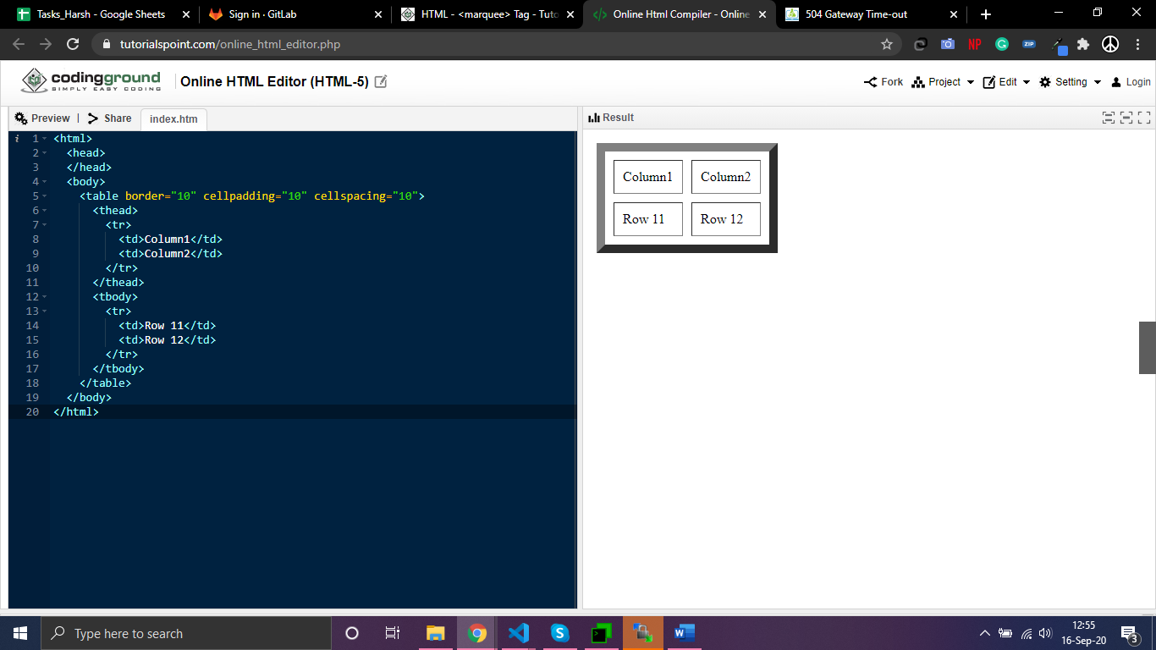

<html>

<head>

<style>

table{

border: solid 4pt black;

border-style: solid;

border-collapse: collapse;

}

td {

border: 4pt solid black;

}

tr{

border: 5pt solid black;

}

</style>

</head>

<body>

<table border="10" cellpadding="10" cellspacing="10">

<tr>

<td>Indian</td>

<td>Italian</td>

</tr>

<tr>

<td><ol>

<li>Item 1</li>

<li>Item 2</li>

</ol></td>

<td><ol>

<li>Item 3</li>

<li>Item 4</li>

</ol></td>

</tr>

</table>

</body>

</html>

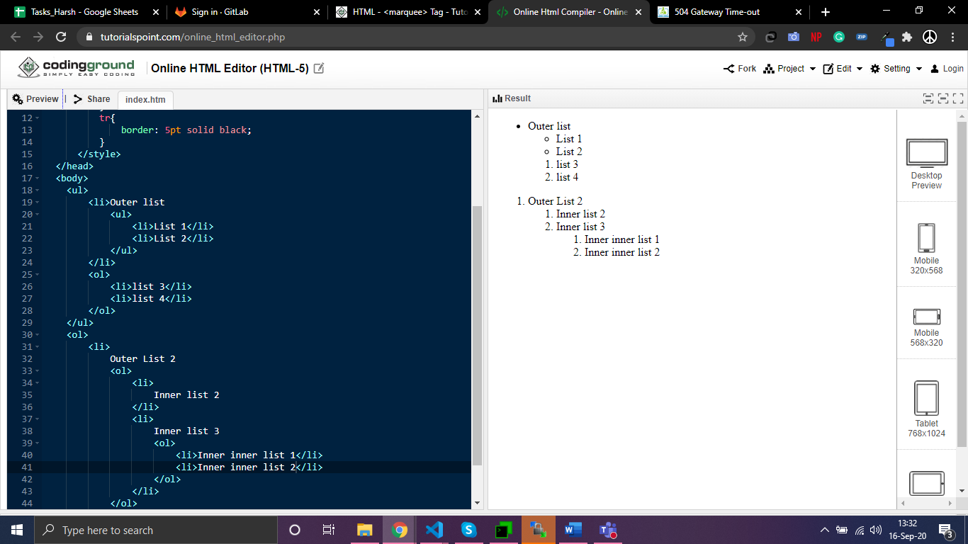

<html>

<head>

<title>

Time Table

</title>

</head>

<body>

<table border="4">

<tr border="4">

<td>Day/Time</td>

<td>9.00 - 10.00</td>

<td>10.00 - 11.00</td>

<td>11.00 - 11.30</td>

<td>11.30 - 12.30</td>

<td>12.30 - 1.30</td>

<td>1.30 - 2.30</td>

</tr>

<tr>

<td>Monday</td>

<td>Sub 1</td>

<td>Sub2</td>

<td rowspan="6" align="center" style="writing-mode: vertical-rl;text-orientation: mixed;">Break</td>

<td>Sub 3</td>

<td>Sub2</td>

<td>Sub 4</td>

</tr>

<tr>

<td>Tuesday</td>

<td>Sub 1</td>

<td>Sub2</td>

<td>Sub 3</td>

<td>Sub2</td>

<td>Sub 4</td>

</tr>

<tr>

<td>Wednesday</td>

<td>Sub 1</td>

<td>Sub2</td>

<td>Sub 3</td>

<td>Sub2</td>

<td>Sub 4</td>

</tr>

<tr>

<td>Thursday</td>

<td>Sub 1</td>

<td>Sub2</td>

<td>Sub 3</td>

<td>Sub2</td>

<td>Sub 4</td>

</tr>

<tr>

<td>Friday</td>

<td>Sub 1</td>

<td>Sub2</td>

<td>Sub 3</td>

<td>Sub2</td>

<td>Sub 4</td>

</tr>

<tr>

<td>Saturday</td>

<td>Sub 1</td>

<td>Sub2</td>

<td>Sub 3</td>

<td>Sub2</td>

<td>Sub 4</td>

</tr>

</table>

</body>

</html>

